 | About the Application  “The Hub” is the online digital platform students will use to submit homework, assignments & Projects. | How do students log-in?  www.houstonisd.org/hub  Example:  Username: Student\sxxxxxxx  Password: 8 Digit Birthday  03062009
 | Renaissance is a student online assessment tool where grades K-5th grade will be screened 3 times a year BOY, MOY, and EOY. (beginning, middle and end of the year) | www.houstonisd.org/digitalresources  Example:  Username: Student\sxxxxxxx  Password: 8 Digit Birthday  03062009
 | Imagine Math is an adaptive, interactive math program that teaches math skills at your student's skill level and helps them practice what they've learned. | www.houstonisd.org/digitalresources  Example:  Username: Student\sxxxxxxx  Password: 8 Digit Birthday  03062009
 | Imagine Math Facts teaches students math facts through a series of powerful, engaging activities on multiplication, division, addition, and subtraction | www.houstonisd.org/digitalresources  Example:  Username: Student\sxxxxxxx  Password: 8 Digit Birthday  03062009
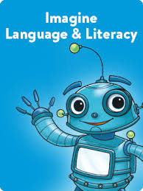 | Imagine Language & Literacy is an adaptive learning solution that accelerates reading and language proficiency for students in grades PreK–6. | www.houstonisd.org/digitalresources  Example:  Username: Student\sxxxxxxx  Password: 8 Digit Birthday  03062009
  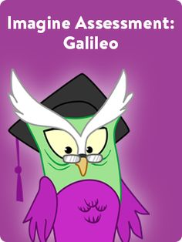 | Imagine Reading teaches reading comprehension, academic discourse, and information synthesis skills to Grade 3 to 8 students through media-rich text sets.  Imagine Assessment Galileo is a Reading/ELA benchmark assessment that assesses students 3 times per year to appropriately place them on their individual instructional path. This comprehensive suite offers real-time reporting tools to reliably track student growth and provide the data to support effective teaching and learning, resulting in high student achievement against college and career readiness standards. | www.houstonisd.org/digitalresources  Example:  Username: Student\sxxxxxxx  Password: 8 Digit Birthday  03062009  www.houstonisd.org/digitalresources  Example:  Username: Student\sxxxxxxx  Password: 8 Digit Birthday  03062009

